**Deploysite link & screenshot Promethesus:**  
<http://18.217.73.69:9090/graph?g0.expr=&g0.tab=1&g0.stacked=0&g0.show_exemplars=0&g0.range_input=1h>

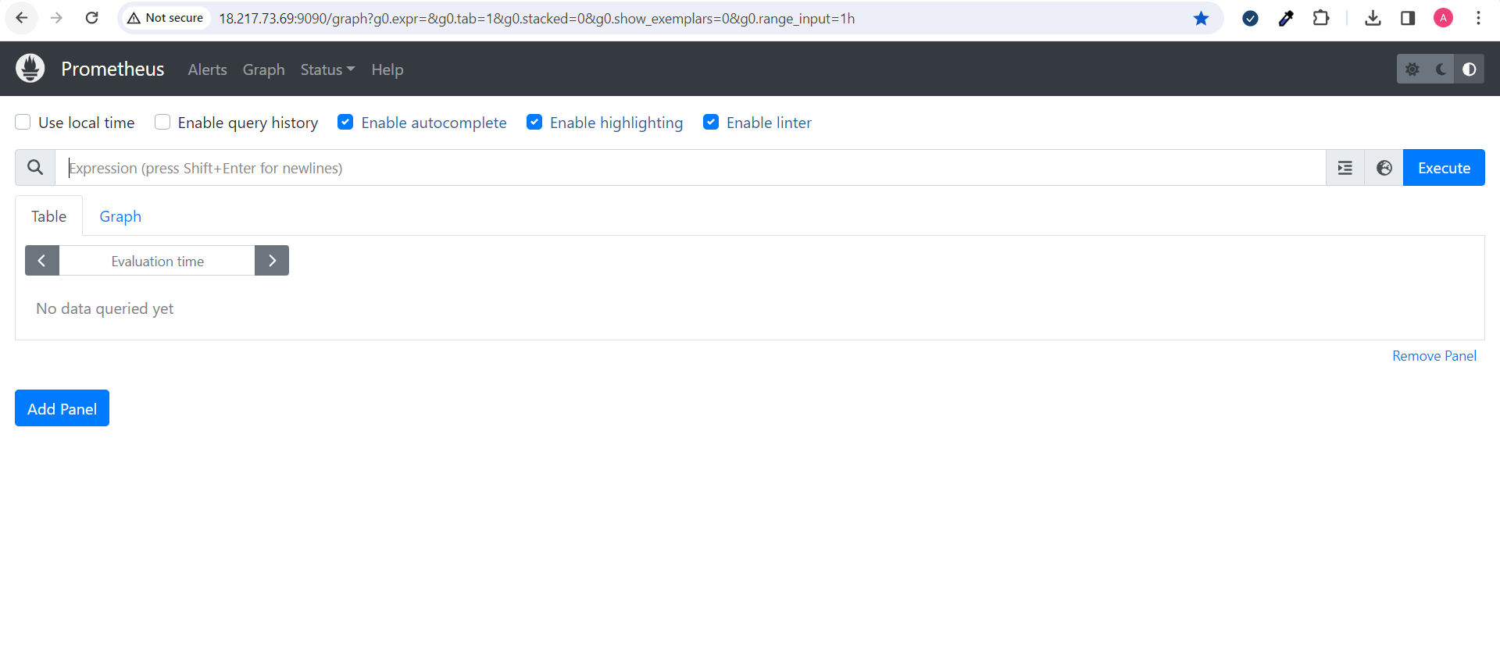

**Monitoring part screenshot & URL Graphana:**  
<http://18.217.73.69:3000/d/garysdevil-kube-state-metrics-v2/kube-state-metrics-v2?orgId=1>

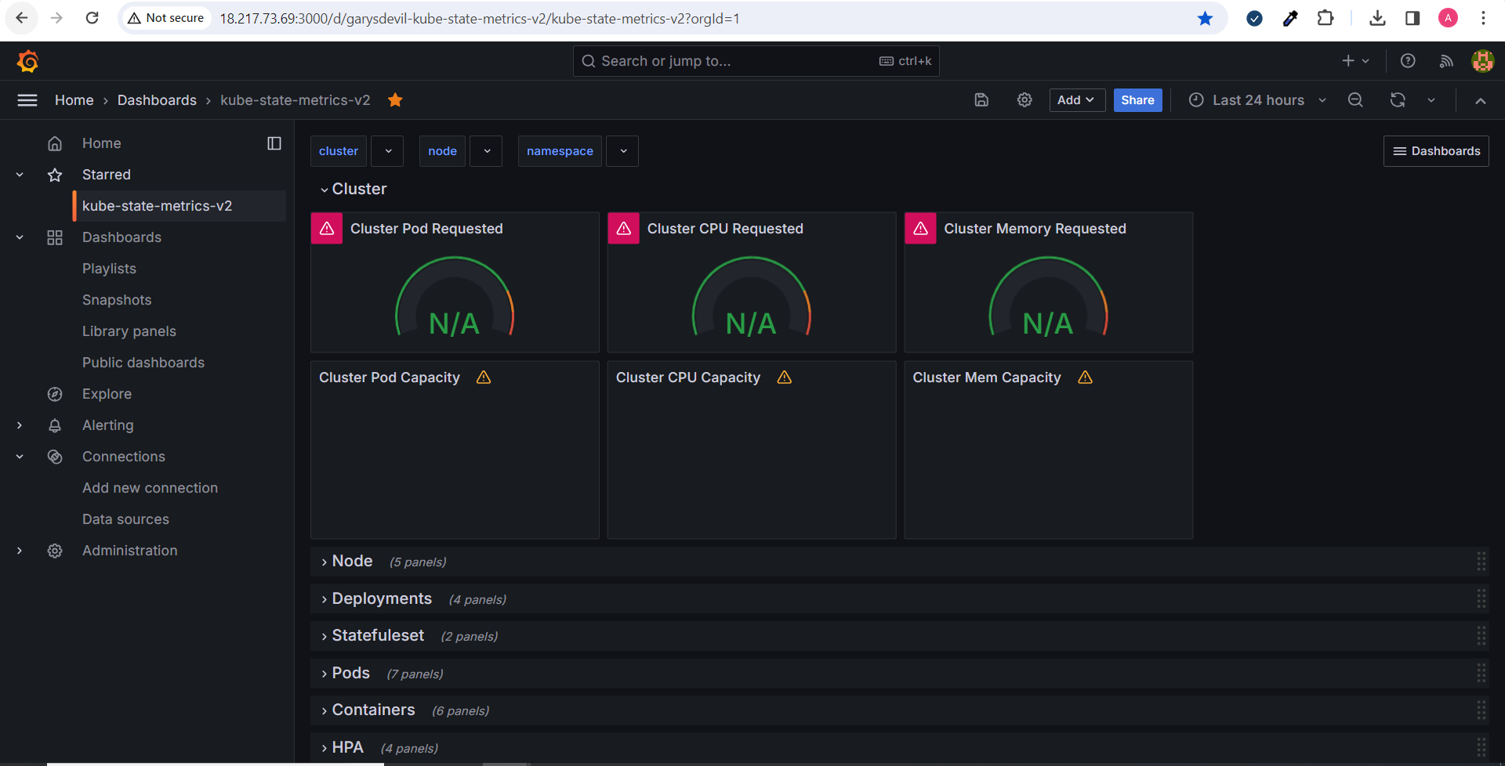

Dockerhub repo:  
  
  
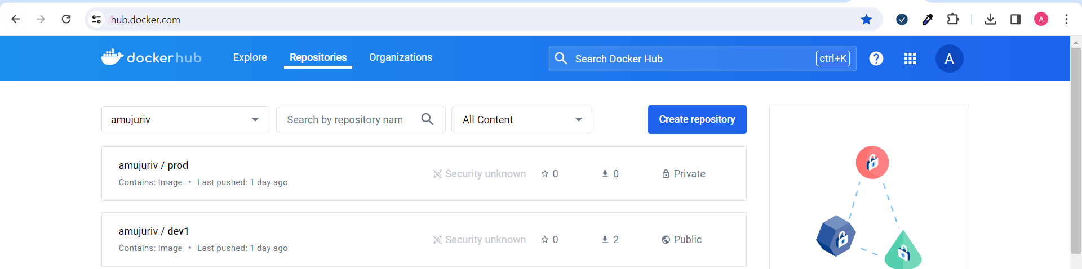

**Jenkins login page & Config setting & executed commands:**

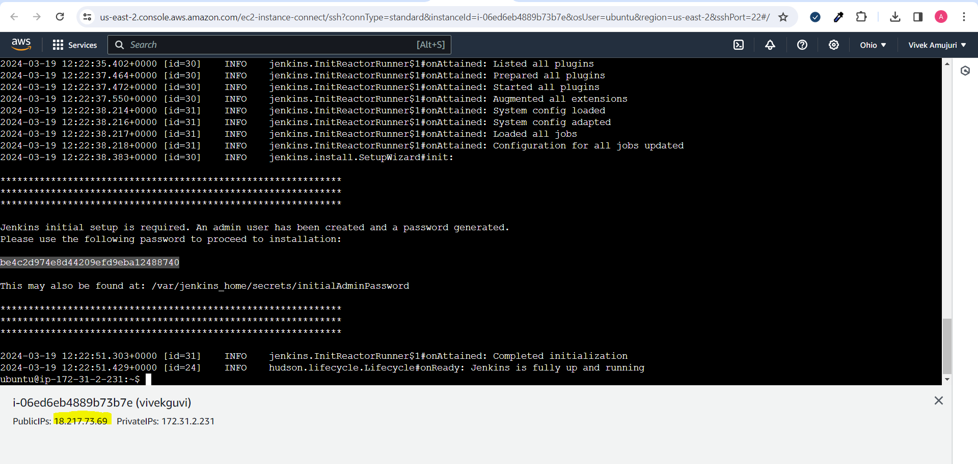

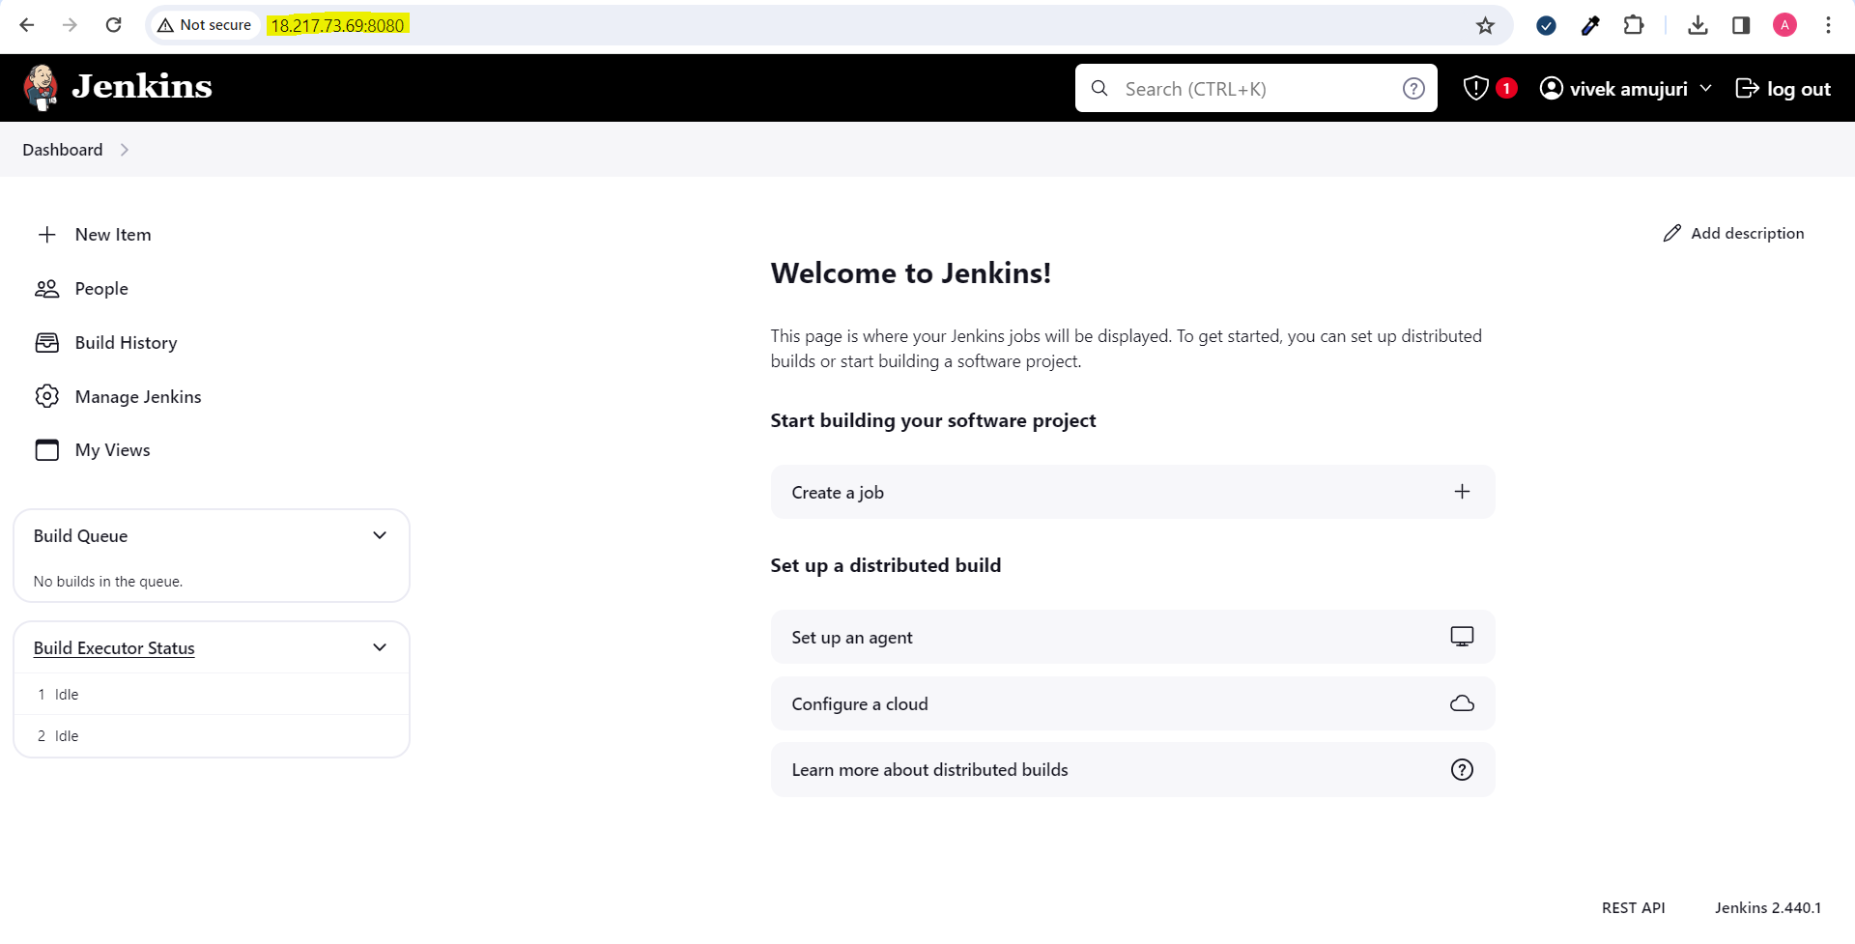

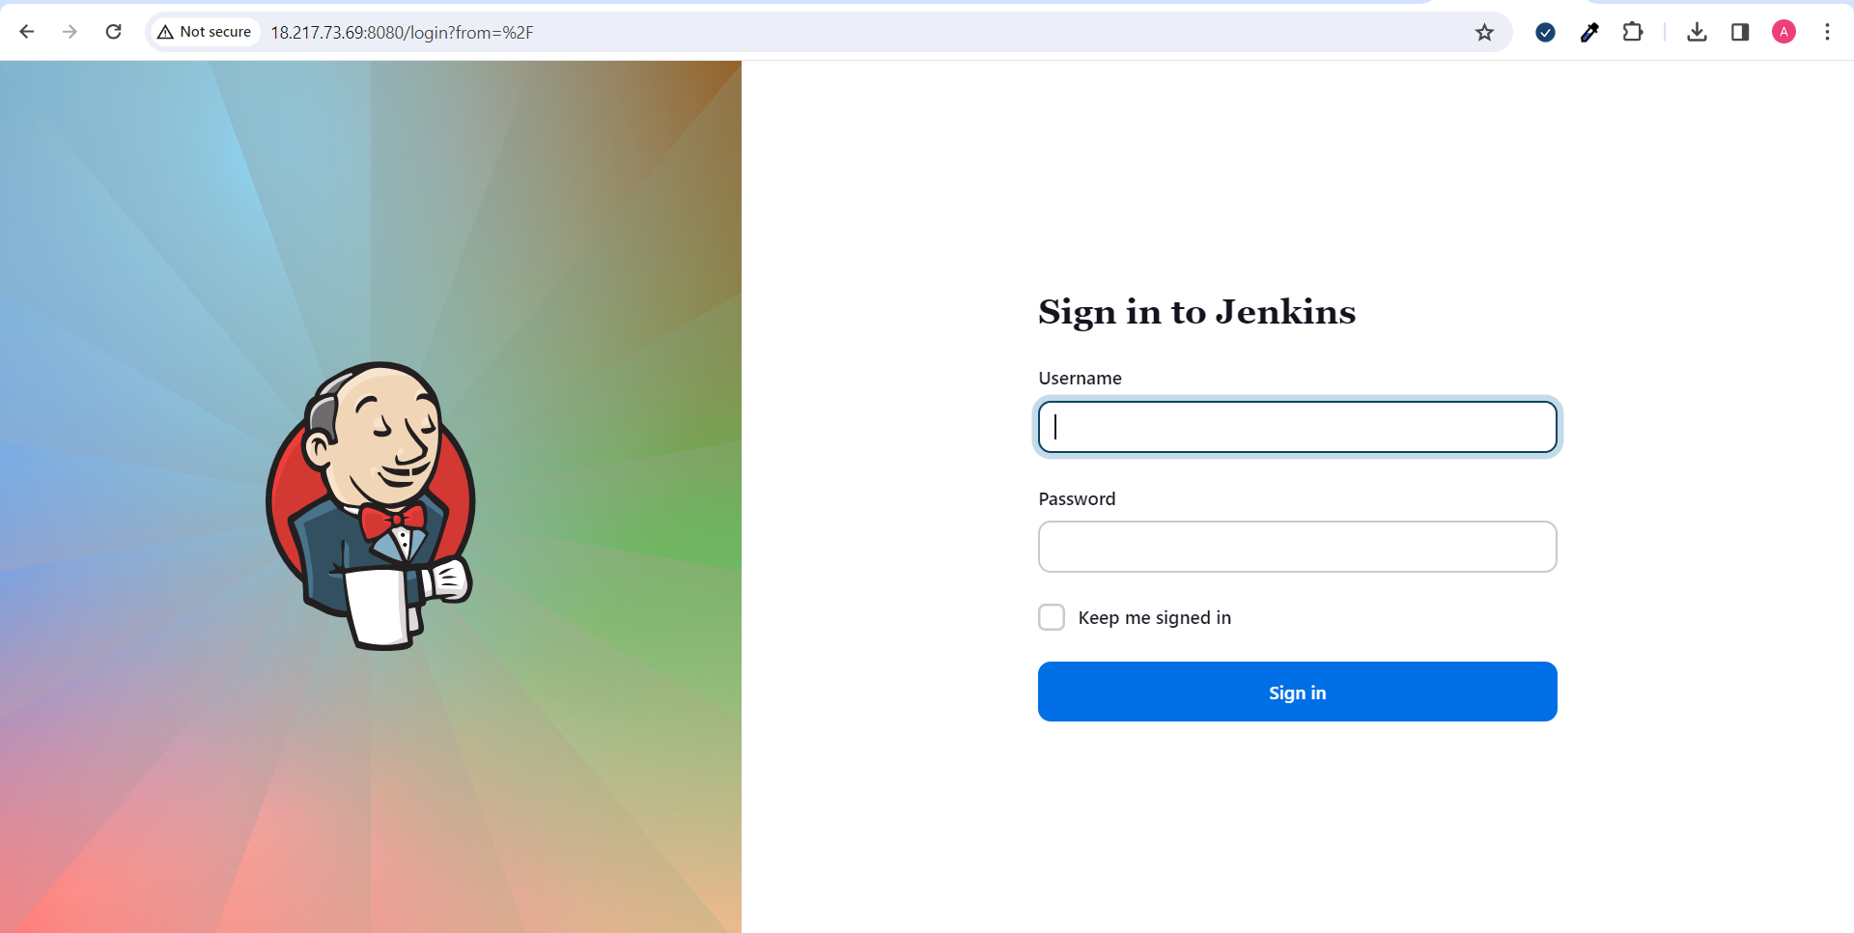

Credentials addition :

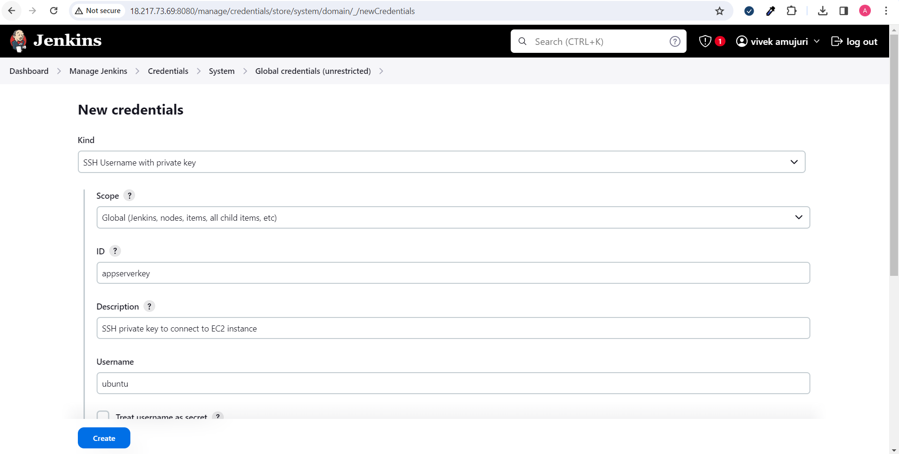

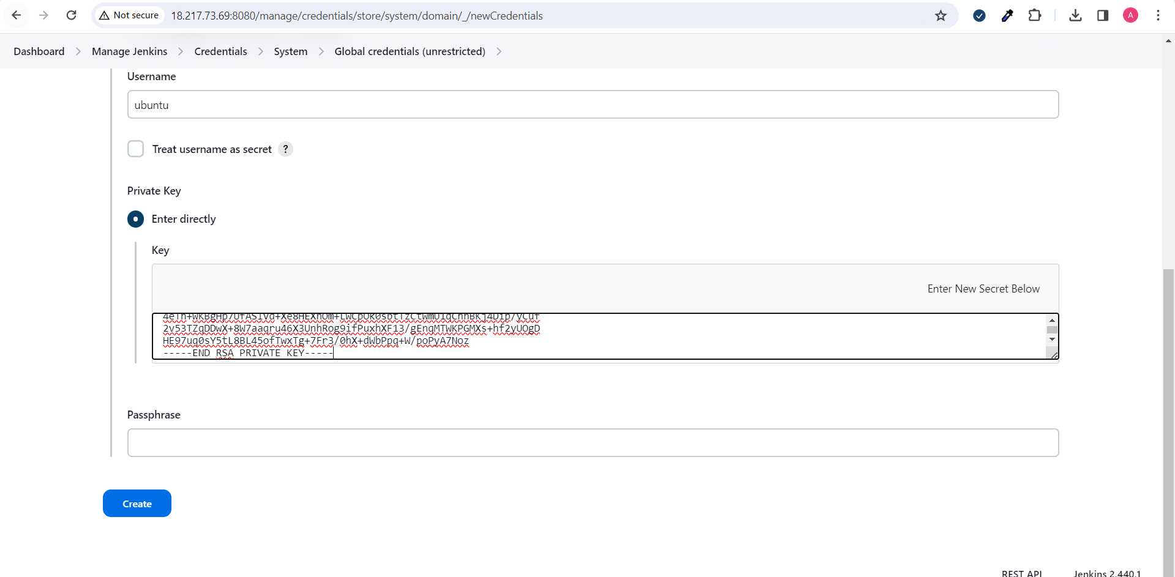

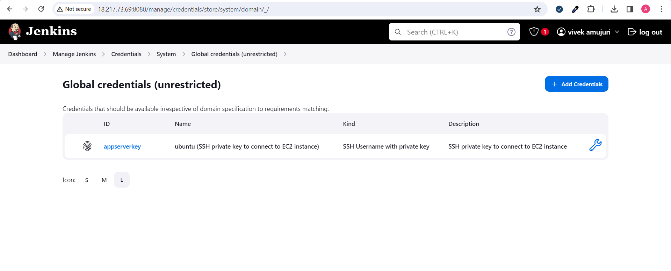

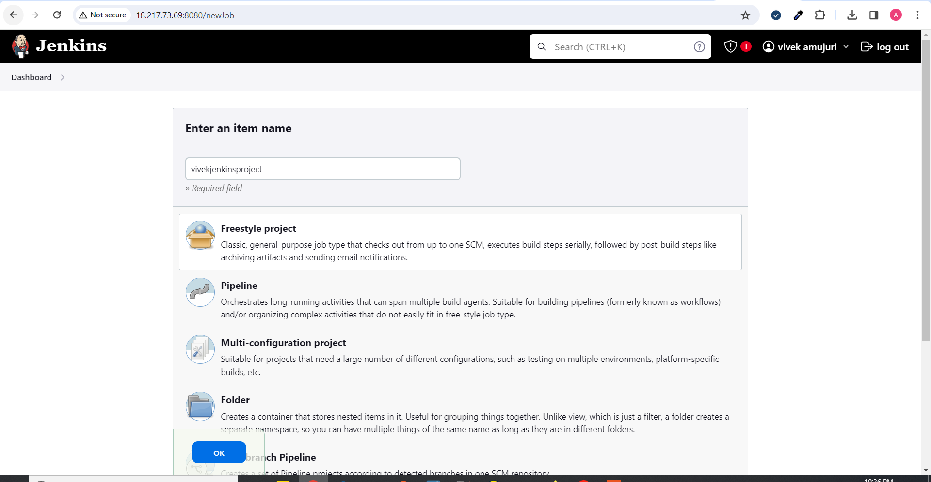

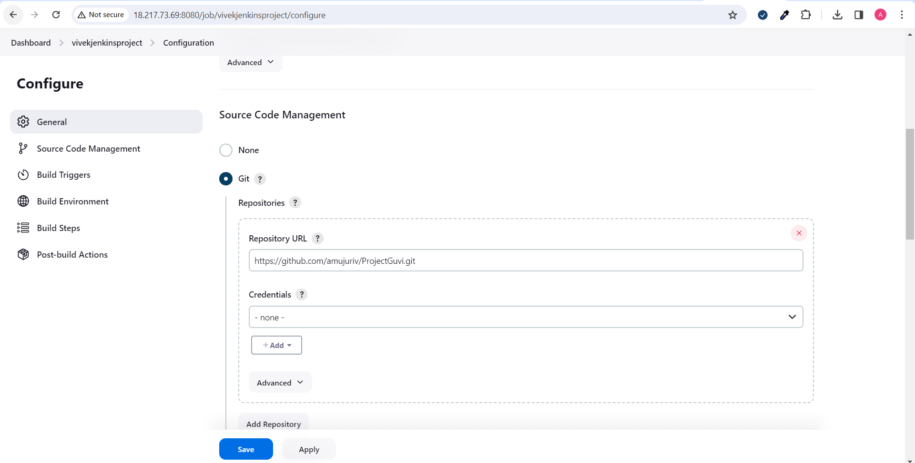

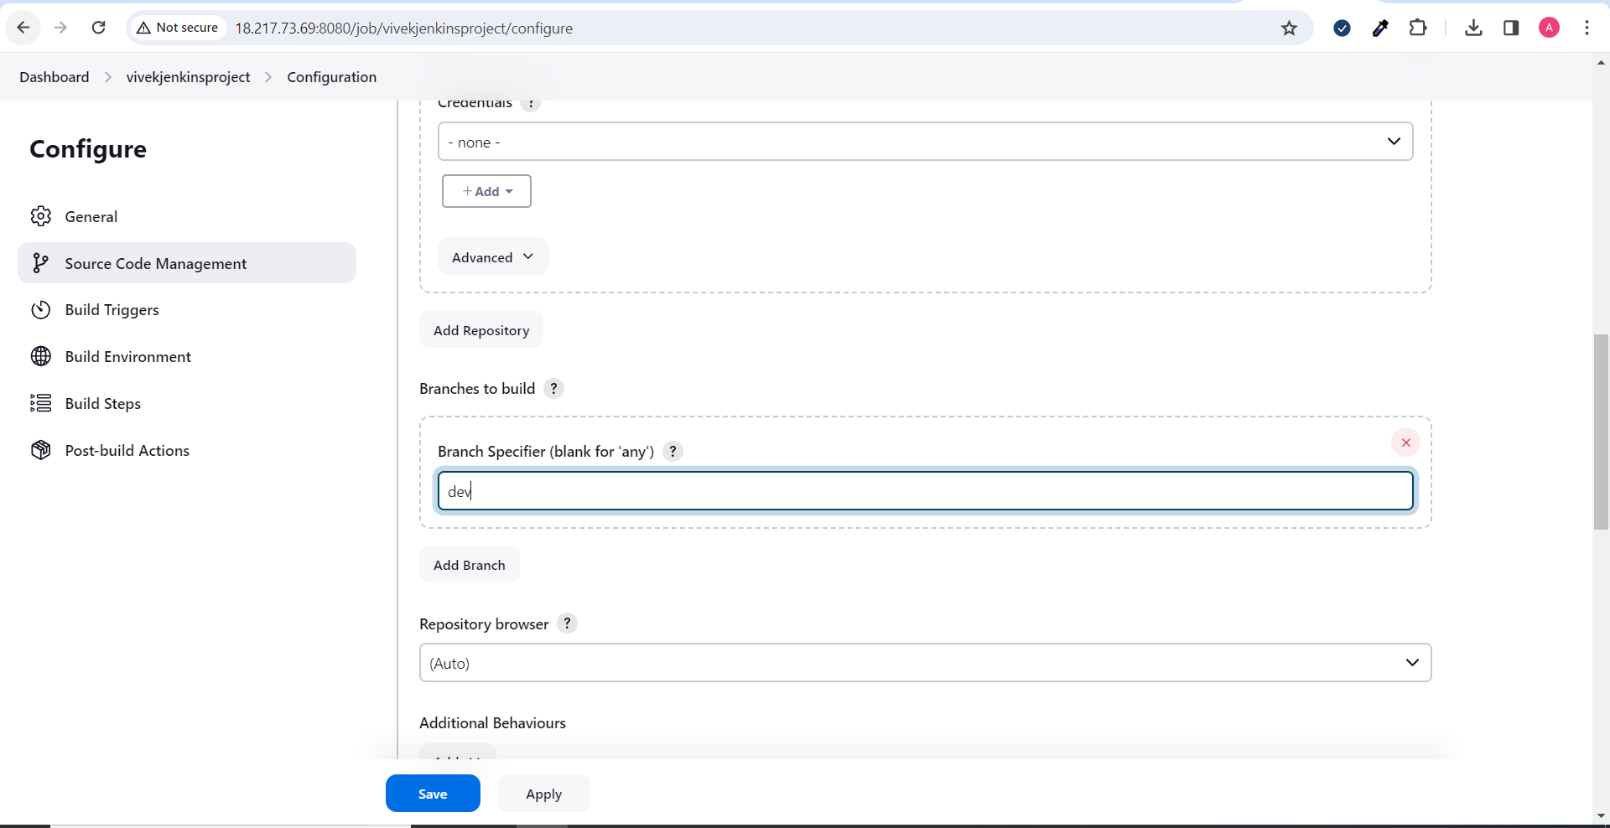

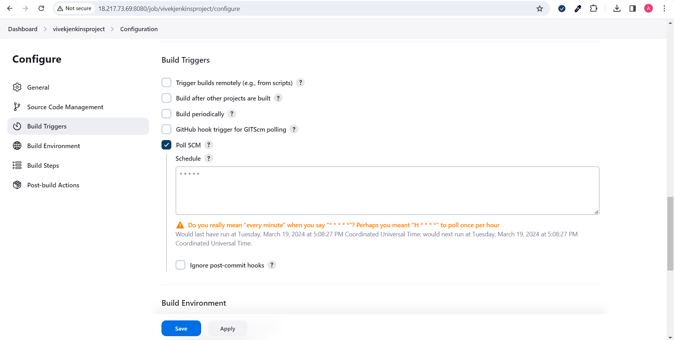

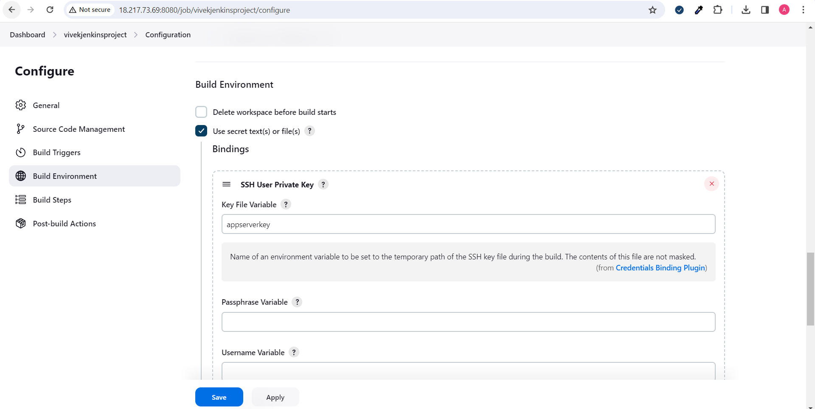

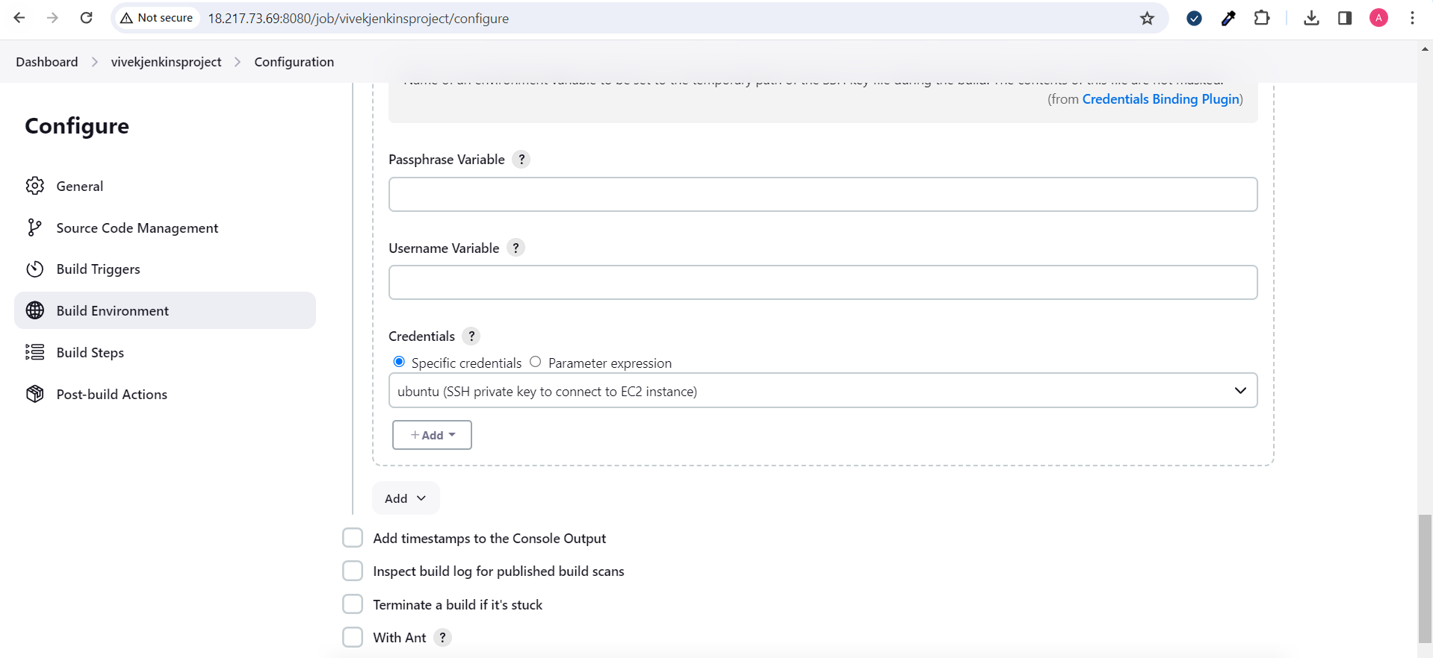

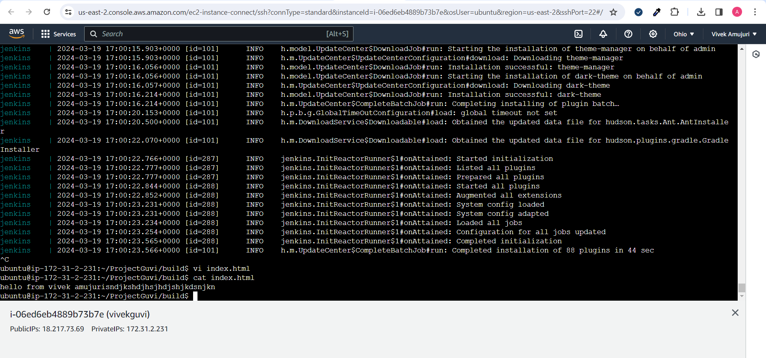

Pushed to repo

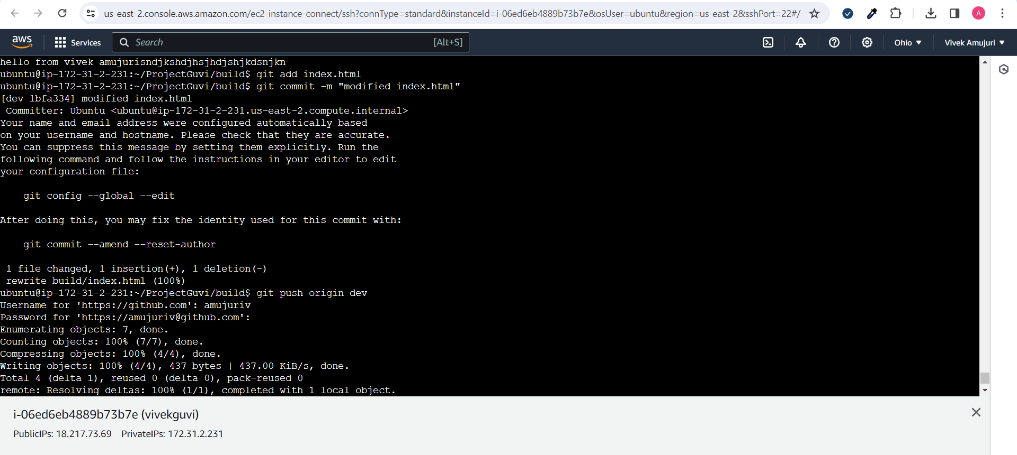

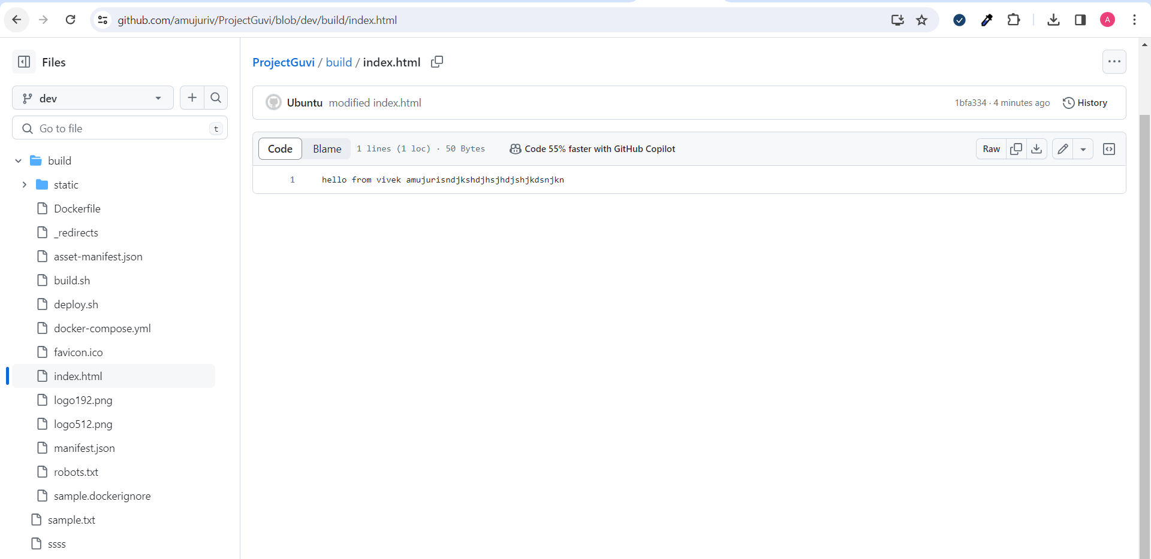

Before automatic deployment

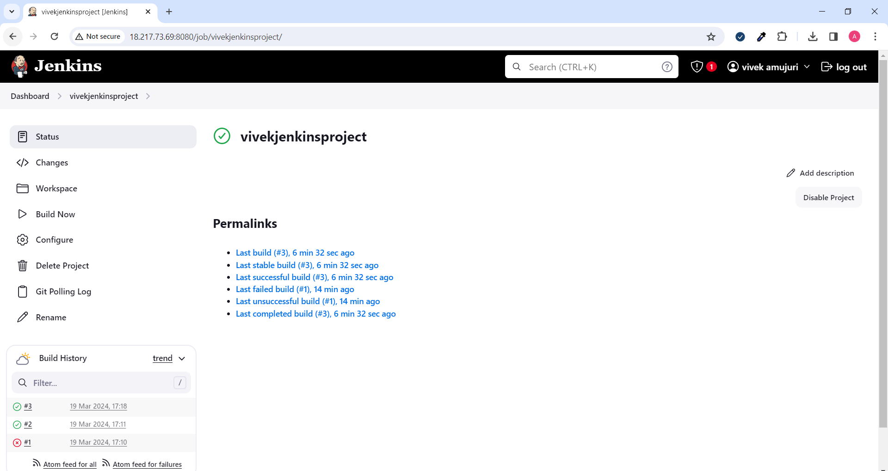

After automatic deployment

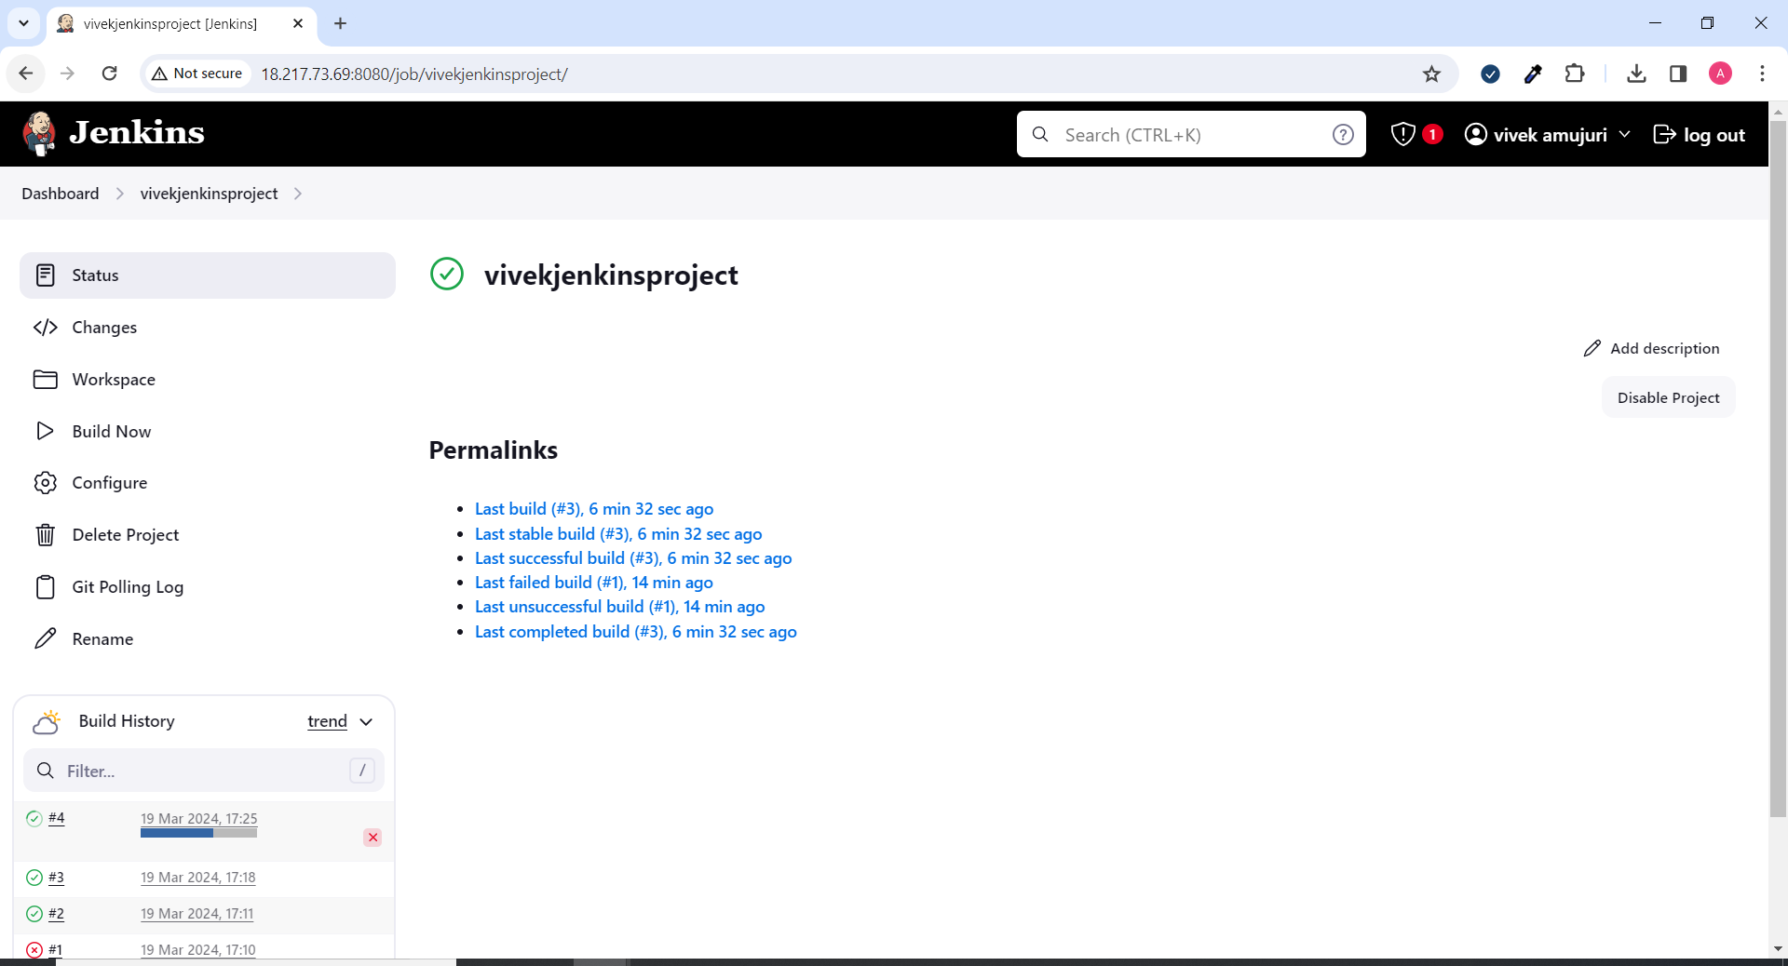

After modifying index.html with above values

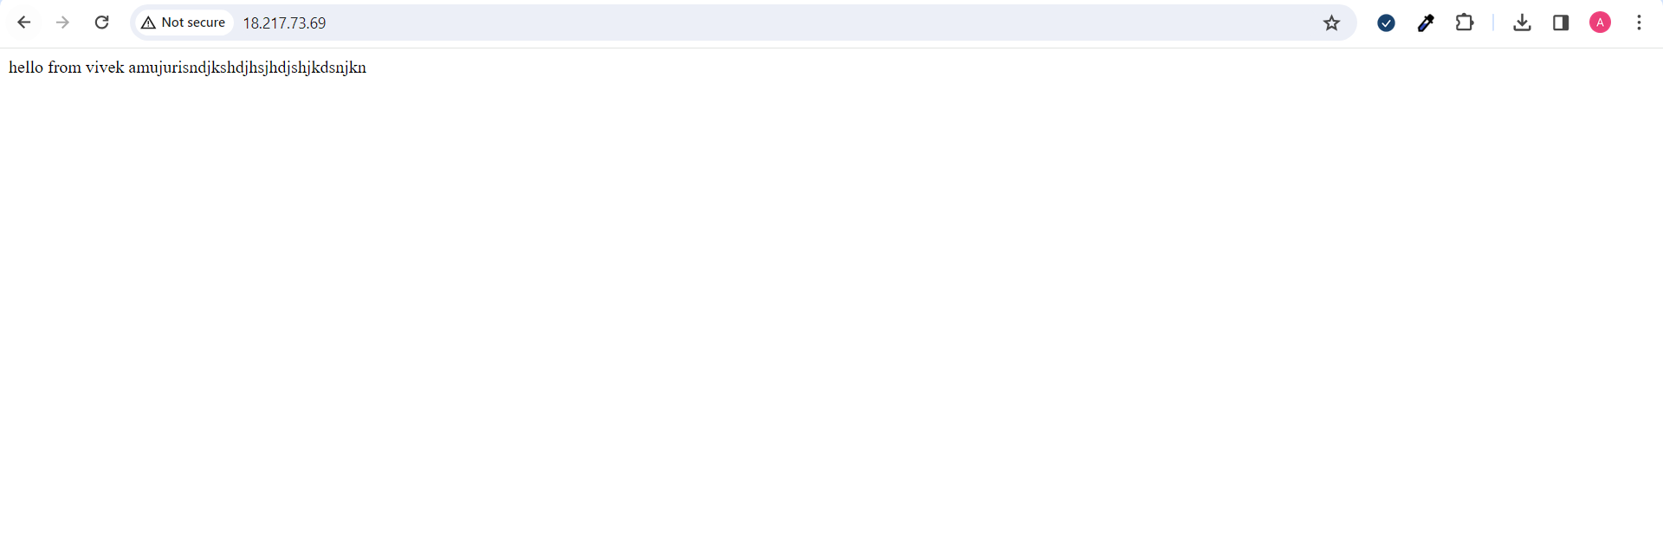

**AWS EC2 & SG configs:**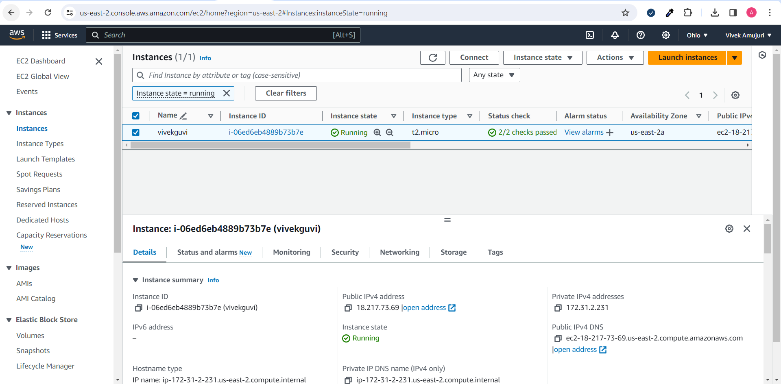

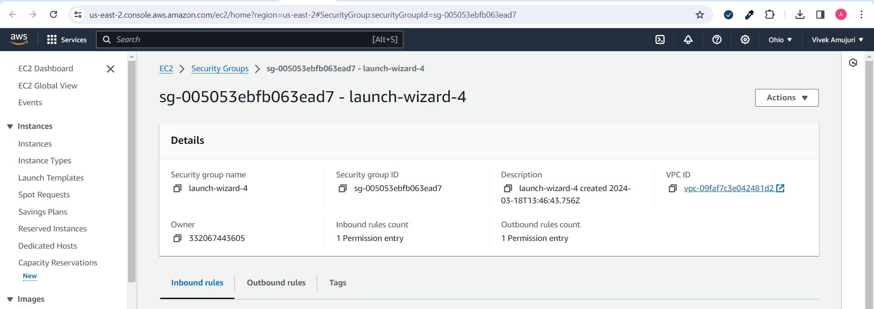

**Docker Images & screenshot:**  
<https://github.com/gauthamreddy923?tab=repositories>  
  
docker images  
ubuntu@ip-172-31-2-231:~/ProjectGuvi/build$ docker images

REPOSITORY TAG IMAGE ID CREATED SIZE

app v1 7a25b8e74d2f 5 minutes ago 185MB

<none> <none> b7287b991155 17 minutes ago 185MB

<none> <none> e8ba53870630 3 hours ago 185MB

<none> <none> 4d6f37d1fccf 5 hours ago 185MB

<none> <none> ca55d6a653e2 5 hours ago 185MB

amujuriv/dev1 v1 31639f49d8f2 26 hours ago 185MB

amujuriv/prod v1 31639f49d8f2 26 hours ago 185MB

ubuntu latest ca2b0f26964c 2 weeks ago 77.9MB

jenkins/jenkins lts dda9cfa9f451 3 weeks ago 462M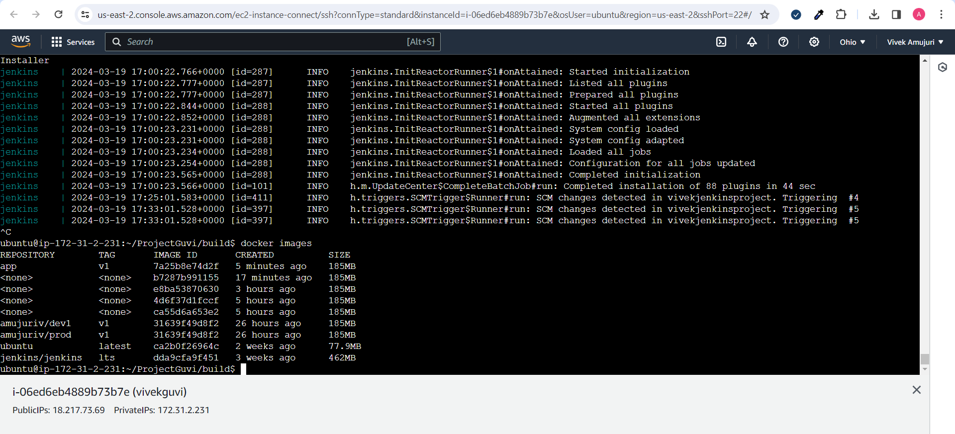

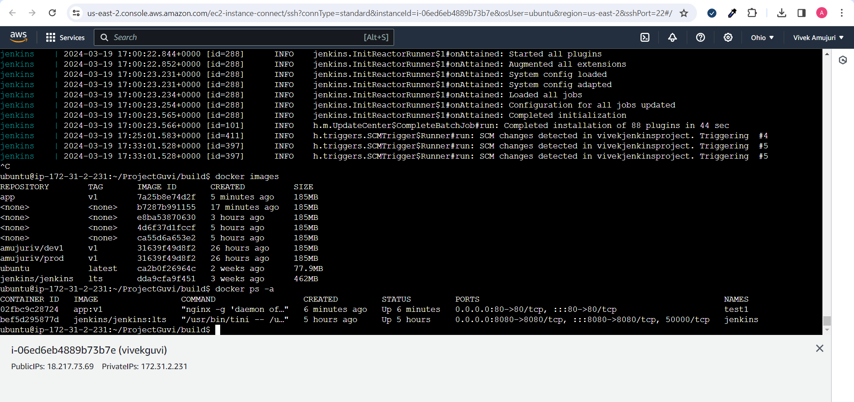

.gitignorefiles

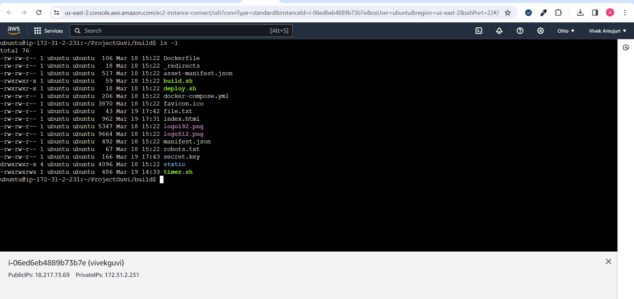

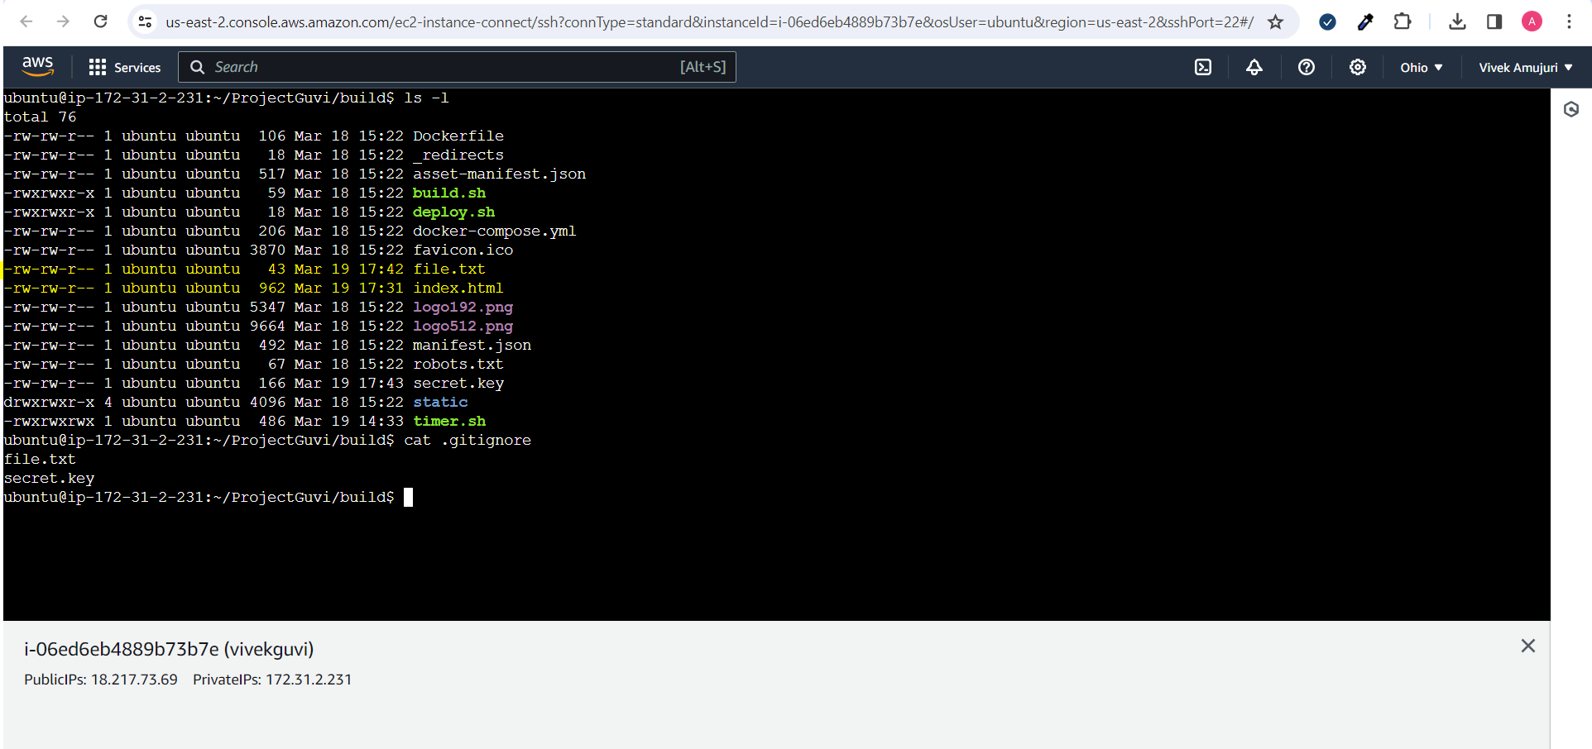

These files did not get pushed to repo

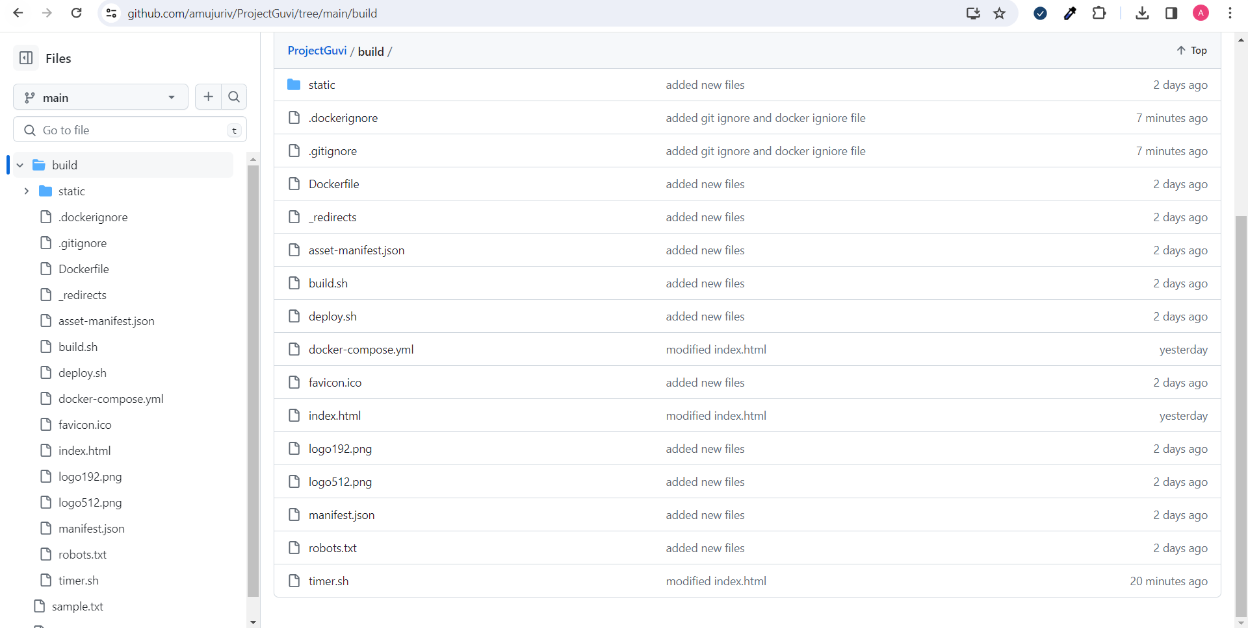

Docker ignore file

